NACAA STATE OFFICERS HANDBOOK

This handbook is updated annually under the direction of the NACAA officers and directors. Its purpose is to provide a handy reference guide of material available from and general policy statements of NACAA. Hopefully, this information will be helpful to the states as they conduct activities of their associations in the years ahead. It is through active and strong state associations that NACAA can continue to prosper and be of more benefit to individual members.

DISTRIBUTION OF THIS HANDBOOK
All state presidents, secretaries, national officers and directors, NACAA Association Policy Committee.

Table of Contents

Section Page
Presidents of State Associations – Duties 2
Bylaws of National Association of County Agricultural Agents 2
Voting Delegates (Number based on state membership) 3
NACAA Annual Meeting/Professional Improvement Conference Polices in Brief 3
NACAA Committees and Committee Structure 4
Selection of National Committee Chairs and Regional Vice-Chairs 6
Statement of NACAA Scholarship Program 8
NACAA Scholarship Application Form 11
Criteria for Awarding NACAA Scholarships 13
Recognition and Awards 14
Eligibility Requirements for NACAA Distinguished Service Awards 14
Eligibility Requirements for NACAA Achievement Awards 16
Nomination Sheet for NACAA Achievement Award 17
The County Agent Magazine 18
State Address Coordinator 18
Obituaries 19
Guidelines and Responsibilities for Secretaries of State Association 19
Regional Officers Workshop 20
NACAA Materials 20
NACAA Service to American/World Agriculture Award 20
Installation Service - NACAA 22
Schedule of Rotation for NACAA Directors and Vice Directors 25
How to Update State Officer and Committee Chairs listed on NACAA website 28
How to Update Membership listing during dues submission process 31
TO PRESIDENTS OF STATE ASSOCIATIONS:

You have been elected president by the members of your association for your leadership abilities. Following are a few guidelines from NACAA to make your term somewhat easier:

- Regularly make necessary changes of membership status and information on the NACAA membership database.
- January and February –
  - Attend NACAA State Officers Workshop at JCEP Leadership Workshop.
  - Select and nominate capable individuals to serve as national committee chairs and regional vice chairs.
- Invite regional director to your state association meeting.
- Get information you wish to have covered at NACAA Board meeting to your regional director.
- Update State Committee Chairs listed on the NACAA website immediately after close of AM/PIC. See directions provided in Appendix I, of this manual.
- When state officers change promptly update state officers listed on the NACAA website.
- Stay in close contact with NACAA professional improvement programs.
- Attend the national Annual Meeting/Professional Improvement Conference.
- Be certain to obtain a copy of NACAA standing committees at the NACAA AM/PIC.
You will also find the committees in The County Agent magazine preceding the AM/PIC or on the NACAA website at www.nacaa.com.
- Read The County Agent. Encourage agents with outstanding programs to write and submit articles to the magazine.
- Work closely with state officers, directors, membership secretary and committee chairs to build a stronger professional improvement organization.
- Read the Bylaws of NACAA.
- The State Officer Handbook is on the NACAA webpage and available for all state officers’ use as needed.

CONSTITUTION AND BY LAWS
The constitution and by-laws of the NACAA are available on the NACAA webpage, www.nacaa.com. State officers are advised to review them so they are familiar with the information available in them for future reference.

VOTING DELEGATES
States are allocated Voting Delegates based on one for the first 40 and one additional for each 30 thereafter or a fraction thereof.

MEMBERS | VOTING DELEGATES
1-40 | 1
41-70 | 2
71-100 | 3
101-130 | 4
131-160 | 5
161-190 | 6
191-220 | 7
221-250 | 8
251-280 | 9
281-310 | 10
311-340 | 11

NACAA ANNUAL MEETING AND PROFESSIONAL IMPROVEMENT CONFERENCE
POLICIES IN BRIEF
(A full and detailed handbook for the Annual Meeting and Professional Improvement Conference is found on the NACAA webpage.)
1. Purpose
a. To provide professional improvement opportunities for members as they strive to improve the effectiveness of their respective programs.
b. To encourage high standards of professional performance.
c. To provide stimuli and incentive on the part of the members to develop new methods, new approaches, and new projects.
2. NACAA Board of Directors is responsible for the Annual Meeting and Professional Improvement Conference. The Annual Meeting and Professional Improvement Conference Committee follows direction of the Board.
3. Selection of Annual Meeting and Professional Improvement Conference sites.
a. NACAA Voting Delegates select location.
b. Board may present to region facts regarding Annual Meeting and Professional Improvement Conference invitations.
4. Annual Meeting and Professional Improvement Conference workshop to be held under direction of the Board at Annual Meeting and Professional Improvement Conference to insure understanding of Annual Meeting and Professional Improvement Conference policies. Annual Meeting and Professional Improvement Conference Committee for the coming year and committees to be responsible for Annual Meeting and Professional Improvement Conferences during the next three years should attend. The designated Past President from the region where the next Annual Meeting and Professional Improvement Conference will be held will carefully review the entire Annual Meeting and Professional Improvement Conference Policy to the group in attendance.
5. Annual Meeting and Professional Improvement Conference budget to be prepared and all bills approved by NACAA President and be paid by NACAA Treasurer who shall be Treasurer of the Annual Meeting and Professional Improvement Conference.

NACAA COMMITTEES

Many NACAA programs are conducted by the committees of the association. The committee structure and duties of the committees are found on the NACAA webpage under the “Committees” link. State officers should be aware of these committees and encourage members to apply for positions when openings occur in their region.

COMMITTEE STRUCTURE

The structure offers much diversity in terms of content and professional opportunities for members along with enhanced flexibility for growth as NACAA strives to be an asset to its members. The committees offer something for everyone; the new extension agent/educator, the mid-career Extension agent/educator, and the full-term Extension agent/educator. Any structure should be built using a strong, broad-based, and solid foundation. The structure for NACAA is built on three foundation blocks that are the basic components of NACAA’s professional enhancement areas: Program Recognition, Extension Development, and Professional Improvement.

PROGRAM RECOGNITION

This component contains the award based programs that have been a historic and traditional part of NACAA. Members can enter competitive contests that highlight the following areas: Communications, Extension Programs, 4-H & Youth, Professional Excellence, Public Relations, Recognition and Awards, and Scholarship. As new competitive awards programs are introduced they would be placed into this block. All programs in this component are expected to identify sponsors and secure adequate funding to operate each award activity. Where possible the sponsor’s funding should include all committee expenses.

Program Recognition Council Committees
- Communications
- Recognition & Awards
- Scholarship
- 4-H & Youth
- Search for Excellence
- Public Relations
- Professional Excellence

EXTENSION DEVELOPMENT

This component is designed to enhance our members in the area of general Extension training. One common thread among NACAA members is the fact that we are all Extension Agents/Educators. Therefore it is imperative that our organization strengthen and continue to offer training on how to become a better extension professional. This is the one area that effectively separates NACAA from other subject specific professional organizations. The Extension Development committees are not subject matter specific, but rather cover broad, general extension related topics that focus on the following: Public Relations and Agriculture Issues, Early Career Development, Administration Skill Development, and Teaching and Communications Skills. Each of these broad headings is a Committee.
Extension Development Council Committees
- Agricultural Issues and Public Relations
- Early Career Development
- Administrative Skills
- Teaching and Educational Technologies
PROFESSIONAL IMPROVEMENT

Over the history of NACAA its members indicated a need for more opportunities to present and receive specific subject matter information. This component of the NACAA committee structure was created and designed to better fulfill this need and the NACAA mission: “.. to further the professional improvement of our members...”,as written in the NACAA mission statement. This area is devoted to enhancing the opportunities for our members to become more knowledgeable and competent in subject matter areas in which they work. Examples of training activities that are included within this category include: discussion groups, seminars, refereed papers, demonstration sharing, study tours, and interstate/international exchanges. Six broad, fundamental subject matter areas were identified that encompass the vast majority of work done by Extension agents/educators across the country. That list includes: Agronomy & Pest Management; Agricultural Economics and Community Development; Animal Science; Natural Resources, Aquaculture/Sea Grant; Horticulture & Turfgrass; and Sustainable Agriculture. Each of these six broad subject matter areas comprises a Committee. Additional committee categories can be added in the future or existing areas modified to better meet the needs of NACAA members. Each of these broad subject matter committees may have numerous advisory groups beneath it as are deemed necessary. Examples of advisory groups under the Animal Science Committee might include: Range/Pasture Management, Bio-Technology in Livestock, Beef Nutrition, Dairy Breeding, Swine Genetics, Rotational Grazing, and Animal Waste Management. This short list is not meant to be all inclusive.
Professional Improvement Committees: (may not exist in all states)
- Agronomy & Pest Management
- Agricultural Economics & Community Development
- Animal Science
- Natural Resources , Aquaculture/SeaGrant
- Horticulture & Turf grass
- Sustainable Agriculture
These Council categories and their associated committees provide new opportunities for NACAA members to make regional and national presentations relative to their individual work experiences. This committee structure provides opportunities for NACAA members to develop and implement regional and even national programs within their discipline that meet objectives and goals contained in their annual Plan of Work (POW).

Selection of National Committee Chairs and Regional Vice-Chairs
Chairs and Regional Vice-Chairs of most committees are appointed to serve two years.
A. How to select members to recommend for appointments to National Committees.
1. They should want to serve on the committee.
2. They should answer correspondence and complete assignments promptly.
3. They should have had experience as active and effective workers in their State Associations.
4. Attendance at past AM/PIC's would be highly desirable and appointees should at least attend AM/PIC for two (2) years following appointment.
5. National committees can function more smoothly, if the member you appoint is serving as Chair of the corresponding State Committee.
B. Recommendations of State Presidents are very important as an aid to the NACAA Board in selecting Regional Vice-Chairs on committees. Provide the following information for the member being recommended.
1. List the number of years served on the National Committee for which member is being recommended.
2. Offices held in State Association.
3. Committees served on in State Association and list of years served as Chair.
4. National AM/PIC’s attended.
5. General Extension program activities.
(State Associations might want to set up a reference file to record this information on the more active members, worthy of consideration as Regional Vice-Chairs or National Committee Chairs.)
STATEMENT OF SCHOLARSHIP PROGRAM
OF
NATIONAL ASSOCIATION OF COUNTY AGRICULTURAL AGENTS
AND
NACAA EDUCATIONAL FOUNDATION
(THIS DOCUMENT MAY NOT BE CHANGED WITHOUT APPROVAL OF THE INTERNAL REVENUE SERVICE)
1. PURPOSE
The purpose of this Scholarship Program is to maintain the high standards of Extension in public service and education by supporting the efforts of the National Association of County Agricultural Agents (“NACAA”) in improving the professional knowledge and skills of Professional Cooperative Extension Service workers (hereinafter “Agents”) working in Extension. Such purpose is to be carried out by granting financial assistance to eligible Agents in the form of scholarships to be applied toward payment for costs incurred in undertaking an approved educational course, seminar, study tour, or similar educational program (all of which are hereinafter referred to as “approved educational course”). Such scholarships are intended: (1) to improve the knowledge and skills of Agents (individuals or groups) to whom grants are made in order to increase their ability to educate the public pursuant to the purposes of Extension; (2) to benefit the public by increased knowledge in agricultural and related matters, to be conveyed through professionally educated Agents; and (3) to maintain high educational standards in carrying out the Extension program of the USDA and the State Land Grant University Systems.

2. NOTICE OF AVAILABILITY OF SCHOLARSHIPS
In order to publicize and make known the Scholarship Program to be carried on by this Foundation, notice of the availability of scholarships under this program shall be sent annually to each NACAA member.

3. SCHOLARSHIP SELECTION COMMITTEE
A Scholarship Selection Committee shall be appointed by the NACAA Board of Directors to evaluate all applications for scholarships. The committee shall be composed of a Chair and five other members, at least one from each Extension region. Each member shall be appointed for a two-year term and, to the extent feasible, on the basis of experience and knowledge in education and training.

4. SELECTION OF RECIPIENTS
Selection of grantees shall be made by the Scholarship Selection Committee on an objective and nondiscriminatory basis, based on the standards set forth in Section 5, below, regardless of the race, creed, color, gender, or religion of the applicant. No scholarship shall be granted to any person, if as a result of such grant, any member of the Scholarship Selection Committee or National Board of NACAA, or any trustee of the Foundation shall derive a private benefit, either directly or indirectly.

5. STANDARDS FOR DETERMINING ELIGIBILITY OF GRANTEES
All scholarships granted under this program shall meet the following standards:
- Each applicant must be a NACAA member in good standing with their State Association for the past two years.
- Each applicant must have contributed a minimum of an amount set by the NACAA Board to the NACAA Scholarship Fund or the NACAA Educational Foundation. Member vestment will be $40 to qualify for up to $1,000 scholarship and a vestment of $100 (an additional $60 contribution to the scholarship fund) to qualify for an additional scholarship awards from $1,001 to $2,000 (no more than $1,000 in any one year will be awarded). Each participant must have made this contribution before the end of the previous year's AM/PIC.
- Each on-line application must describe in detail the educational purposes of the requested grant, how such educational course will improve the competency of the applicant as an Extension professional, and the educational costs for which the grant is requested.
- Each application must be submitted to the Scholarship Selection Committee by June 1.

6. STANDARDS AND PROCEDURE IN GRANTING SCHOLARSHIPS

- The amount and number of scholarships shall be recommended annually by the Scholarship Selection Committee and approved by the Trustees of the Foundation. No scholarship shall exceed $1,000 per person annually with a $2,000 lifetime maximum, except as may be determined by the Trustees of the Foundation in unusual circumstances. Scholarships are not continuing or renewable.
- Scholarships may be awarded for undertaking an individual or group-approved educational course, which may involve an advanced degree, graduate credit, study tour, educational seminar, research, or other specialized training program. Scholarships shall be awarded in accordance with the purposes stated in Section 1 of this statement.
- Scholarship payments will not be made until 30 days prior to beginning the approved educational course. It is the grantee’s responsibility to advise the Scholarship Selection Committee of the date that the approved educational course is to begin.
- The approved educational course (1) must start within one year or by the next Annual Meeting of the NACAA following the Annual Meeting at which the award is made, and (2) cannot be initiated before the application is approved by the Scholarship Selection Committee.
- Grantees shall be named at the Annual Meeting of the NACAA.

7. SUPERVISION AND RECORDS
- Each grantee must file a written report with the Chair of the Scholarship Selection Committee within 30 days after the completion of the approved educational course for which the award was made. Such reports shall be reviewed by at least one member of the Scholarship Committee.
- Where any of the reports indicate that the scholarship proceeds are not being used in furtherance of the required educational purposes, the Scholarship Selection Committee shall make an appropriate investigation into this matter. If such proceeds have been used for improper purposes, no further scholarship awards may be made to such grantee (regardless of whether the impropriety is corrected) and the Scholarship Selection Committee shall take all necessary and appropriate action to obtain repayment of the scholarship funds which have been misused.
- The Scholarship Selection Committee shall maintain and retain records and files with regard to the Scholarship Program.
- Such records shall include:
- All information secured to evaluate the qualification of all applicants for scholarships under this Scholarship Program.
- Identification of scholarship grantees.
- Specification of the amount and purpose of each scholarship.
- All information pertaining to supervision of each grantee, as set forth in paragraphs (a) and (b) above.
(Revised 3/94)
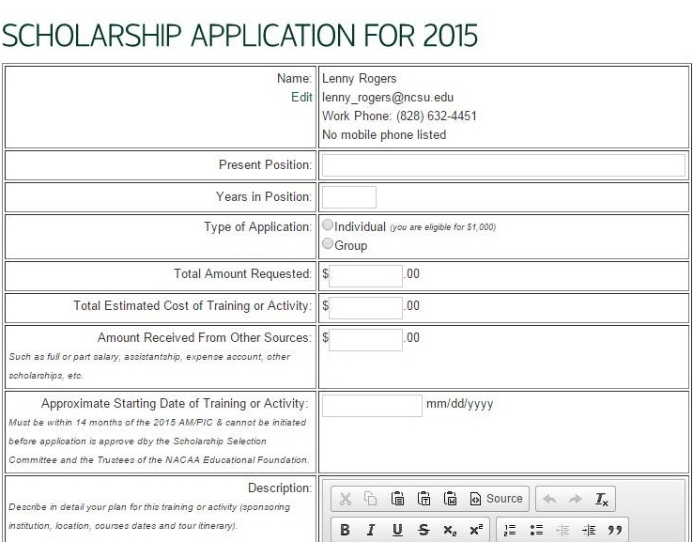

Criteria for Awarding Scholarships:
- Application must carry signature of State Association President, State Scholarship Chair and Appropriate State Extension Administrator.
- Each participant must have contributed at least $40 to the NACAA Scholarship Fund by the end of the NACAA AM/PIC of the previous year. (If one person within the group has not contributed $40 by the end of the previous AMPIC, it disqualifies the entire group).
- Study must start within one year or by the next AM/PIC following the AM/PIC at which the award is made.
- Must describe in detail the training and how it will help improve the competency of the Extension professional.
- Award is for individual or group professional improvement which may include advanced degrees, graduate credits, tours, seminars, research or other specialized training.
- Maximum scholarship is $2000 during Extension career. (This amount includes scholarships received as an individual or as part of a group.)
- Study or training cannot be completed before the application is approved by the Trustees, NACAA Educational Foundation.
- Scholarship funds will not be awarded until 30 days prior to study or training begins. It is the recipient’s responsibility to advise the National Scholarship Chair if impending date of educational activity changes.
- Report must be made to National Scholarship Chair within 30 days after the training is completed.
- Recipients will be selected by the Scholarship Selection Committee with final approval of the Trustees, NACAA Educational Foundation.
- No scholarship will be awarded a person, if as a result of such grant, any member of the Scholarship Selection Committee, National Board of NACAA, or any Trustee of the Foundation shall derive a private benefit, either directly or indirectly.

Send seven (7) copies of the application form to the Scholarship Committee State Chair by June 1. Six copies will then be sent on to the Regional Vice-Chair prior to June 15. Applications must reach the National Chair by July 1.

FOR GROUP APPLICATIONS - All tour members must meet criteria, including address and social security number, home and office phone, contribution of $40 to the NACAA Scholarship Fund by the end of AMPIC the prior year, whether they received a previous scholarship and if so, how much. List this on a separate sheet of paper and attach to the scholarship application.

(Do not use older application forms)
RECOGNITION AND AWARDS

The objective of the Recognition and Awards Committee shall be to provide leadership in the recognition of outstanding accomplishments by NACAA members including the selection and appropriate recognition awards programs. They shall administer, with the approval of the Board of Directors, the selection and presentation of the Distinguished Service Award, the Achievement Award and Hall of Fame Award.
The Distinguished Service Award shall be presented to members who have served at least 10 years as a member of the Cooperative Extension Service, who have conducted outstanding programs, are held in high esteem by their fellow workers, and are approved by the State Director of Extension. They must be members of their State and National Associations the year that they are selected. States are allocated DSA's based on each state’s membership as of February 15 of the previous year. Each state is entitled to DSA's based on 2% of its membership or major fraction thereof. No unfilled quotas can be carried over and applied to future quotas. Recipient must attend Annual Meeting to receive award, unless exempted by Committee Chair because of extenuating circumstances. (Established by Board action, August, 1993.)
Members DSA’s
1 - 75 1
76 - 125 2
126 - 175 3
176 - 225 4
226 - 275 5
276 - 325 6
326 - 375 7

ELIGIBILITY REQUIREMENTS
FOR NACAA DISTINGUISHED SERVICE AWARDS

The Nominee:

- Shall have served a total of at least 10 years with outstanding service as a member of the Cooperative Extension Service. Must be a member of the NACAA when selected. The cut-off date for determining years of service is February 15 of the current year. Exception: Specialists or others who have only recently been accepted by their State Association must have 10 years or more Extension work experience and been a state member since membership became available in this person’s state.
- Should have worked out and put into effect an effective Extension program which includes carrying to completion some constructive and outstanding work. Be specific. Military duties, church work, and civic activities do not apply.
- Shall be actively interested in the improvement of the Cooperative Extension profession. Should participate in the affairs of the State Association and constructively support its program.
- Should have studied some specific Extension subject by group study, correspondence, university residence study, or should have pursued some other means to improve his abilities.
- Must have the recommendation of the State Extension Director.
- Recipient must attend Annual Meeting and Professional Improvement Conference to receive award, unless exempted by Committee Chair because of extenuating circumstances. (Established by Board action, August, 1993.)

General Requirements:

- Nominations are limited to 2% and/or major fraction thereof, of the membership of each state. This will be based on the membership paid the NACAA Treasurer on February 15 of the previous year.
- Each State (or district) Association may nominate one nominee, irrespective of the number of Agents.
- A State Association is not required to make a nomination.
- Recognition and Awards Committee of the NACAA must give the final approval on all nominees for awards to be made at the Annual Meeting each year. No publicity should be given until this approval is given to state Extension Directors.
- All information should be in the hands of the National Chair Recognition and Awards Committee not later than the deadline date set by National Committee Chair each year.
(Revised 10/1994)

ELIGIBILITY REQUIREMENTS
FOR
NACAA ACHIEVEMENT AWARDS

Purpose: The purpose of the Achievement Award Program is to encourage and recognize excellence in the field of professional Extension for members with less than ten years of service.
Selection: Each year, each State Recognition and Awards Committee may submit the names of 1% or fraction thereof of the state’s membership based on each state’s membership as of February 15 of the previous year, with a minimum of one agent per state. A nomination form is available from the National Recognition and Awards Committee Chair. All winners must be approved by their State Director. Winners will be submitted at the same time as DSA nominees. Recipient must be a member of NACAA when selected and must attend Annual Meeting and Professional Improvement Conference to receive award, unless exempted by Committee Chair because of extenuating circumstances. (Established by Board action, August, 1993.)
Recognition: A Certificate of Achievement will be presented by NACAA to each state winner during the Regional Meetings and the Annual Meeting and Professional Improvement Conference of NACAA. All names will also be listed in the DSA Brochure.

Members | AAs
1-75 | 1
76-125 | 2
126-175 | 3
176-225 | 4
226-275 | 5

Note: NACAA urges State Associations to recognize their state winners at the State Annual Meeting and Professional Improvement Conference and encourage winner (financially, if possible) to attend the National Meeting. Please forward winner’s nomination through the awards submission process to the National Chair Recognition and Awards Committee along with DSA nominees.
The Achievement Award shall be awarded to Agents with less than 10 years of service in the Cooperative Extension Service who have exhibited excellence in the field of professional Extension. Nominees must be members of the State and National Association the year that they receive the award and have the approval of their state Extension Director. A quota (established by Board action April, 1992 to begin in 1993) shall be 1% or fraction thereof of the state’s membership based on each state’s membership as of February 15 of the previous year with a minimum of one agent per state. No unfilled quotas can be carried over and applied to future quotas. Recipient must attend Annual Meeting to receive award, unless exempted by Committee Chair because of extenuating circumstances. (Established by Board action, August, 1993.)

An Achievement Award nomination sheet is included on the following page. It is not required for
a nomination sent to NACAA. It is intended for use within states to assist with their selection process.
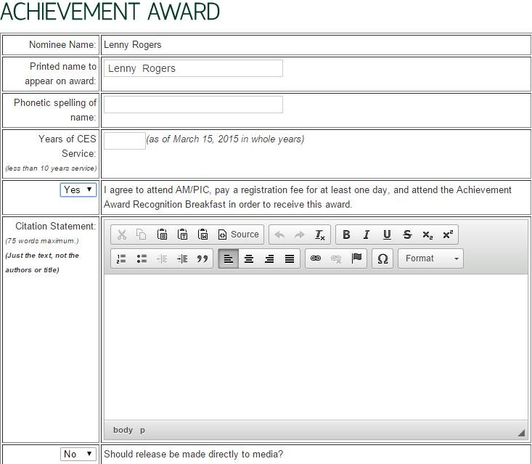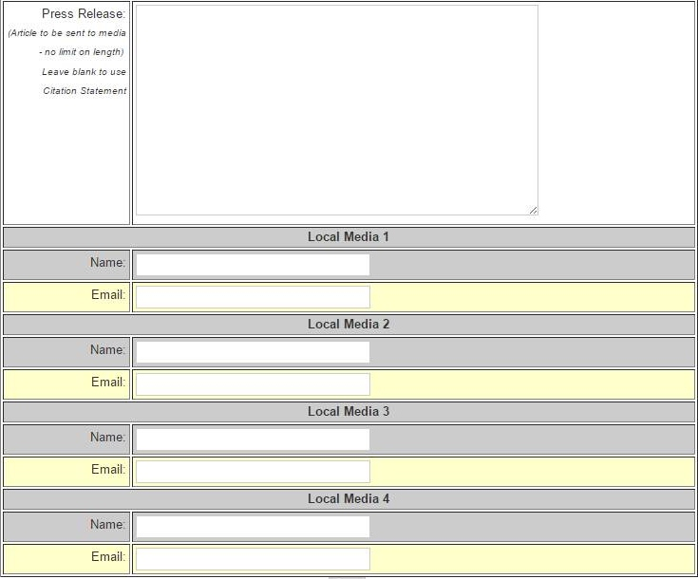

THE COUNTYAGENT MAGAZINE

The County Agent is published four times per year. Some of the suggestions listed below may be of help in improving the quality, readability and circulation of The County Agent.

1. When a member has a change of address, the individual should notify the secretary of their State Association or their state address coordinator. The address change should be made in the NACAA member database.
3. News articles are welcome from all states. Digital format is preferred for ease of editing and formatting for the magazine.
4. Good pictures that are clean and clear, preferably 5" x 7", may be used at all times. People should be grouped so that the picture may be “cropped”. The description under pictures should definitely carry the name of the state as well as all news articles.
5. News stories may cover information dealing with the state association, the Cooperative Extension Service in relation to the NACAA or stories that may be of educational value to members throughout the Unites States.
6. Recognize our Life Members: special stories often bring old friends together.
7. Agribusiness and county agent stories with good pictures are always of value.
8. When a member does not receive The County Agent, it may be due to an incorrect or incomplete address. Sometimes it is due to states holding membership for an extended period. Therefore, please have your state secretary-treasurer mail dues early in the year (January) and certainly by February 15.
9. NACAA members should be aware that three copies of The County Agent magazine are provided free with each state association deciding who should receive complimentary copies in their state. Complimentary issue forms are available on the NACAA website at www.nacaa.com.
10. The County Agent will now also be available in digital format on the NACAA website.

STATE ADDRESS COORDINATOR

It is of the utmost importance that each state has an address coordinator to maintain a correct updated membership list, including Life Members. The state address coordinator must promptly correct all address and status changes (including deaths, life members, etc.) in the on-line member database which is accessed through the NACAA web site: www.nacaa.com .

In many states, the secretary or another state officer might be the address coordinator, but in most states the office of address coordinator should be a position with no other association responsibilities and be for a term of five (5) years or more. It is vital that every state strive to keep their membership list current and up-to-date, and that members’ names and complete addresses be put in the database as dues are paid.

An effective state address coordinator may be of great value to the state organization by:
1. Executing membership forms for the state secretary;
2. Providing state committee chairs with addressed envelopes for presenting state and NACAA programs;
3. Creating and maintaining accurate records for all needs.

OBITUARIES
Upon the death of a current Board member, Committee Chair, Committee Vice-Chair, or a past National officer, a brief report of the passing will be forwarded to the Editor of The County Agent. NACAA Regional Directors and State Presidents are encouraged to assist in implementing this policy. (Revised 12/95)

GUIDELINES AND RESPONSIBILITIES FOR SECRETARIES
OF STATE ASSOCIATIONS AFFILIATED WITH THE NACAA

State Secretaries are responsible to provide the NACAA changes in offices in their state association. State Secretaries’ communication with NACAA should be with the National Secretary.
Officer Changes:
Since each state elects new officers at different times of the year, it is the responsibility of the State Secretary to notify the NACAA Secretary as soon as the state elects new officers and see that the NACAA member database is updated with the new leadership.

1. Officers that should be reported in the NACAA member database include the following:
President
President Elect
Vice President
Secretary
Treasurer
Address Coordinator
2. Include names, office address, city and zip code, office phone, fax number and e-mail address.
3. Indicate the date the new officers will assume the new office and when their terms will end. (This provides the NACAA secretary knowledge of when your state’s officers will change again.)
4. At any time if positions, addresses, or phone numbers change for officers, the state secretary should correct the NACAA member database.

Voting Delegates
Each year approximately 60 days before the next NACAA Annual Meeting/Professional Improvement Conference, the NACAA Secretary will request a list of voting delegates and alternates for the Annual Meeting. The number of voting delegates each state is allowed is based on your state’s membership on February 15 of the year of the Annual meeting/Professional Improvement Conference.
State Secretaries should work with their state officers to select voting delegates prior to time the NACAA Secretary requests the information. Information needed includes: name, address, city, zip code, phone number, fax number and e-mail address.

OFFICERS’ WORKSHOP (formerly called the regional workshops)

Objectives:
1. To increase Educators’/Agents’ knowledge of current activities designed to increase support for Extension on the state and federal level.
2. To increase Educators’/Agents’ effectiveness in supporting lay leaders as they contact decision makers on the county, state, and federal level to gain support for Cooperative Extension.
3. To further define the role of the agent and the Educators’/Agents’ Associations as they work in concert with ECOP and state Extension administration in the area of legislative support.

NACAA MATERIALS

- Membership promotional materials are updated periodically and available upon request from the Executive Director’s office.
- Code of Ethics (available from the NACAA Executive Director)
- By-laws and Duties – In the NACAA policy handbook on NACAA webpage
- Duties of NACAA Officers, Directors and Committees – On NACAA webpage
- NACAA Policy – On NACAA webpage
- NACAA State Officers Handbook (For State Presidents and Secretaries). Available on NACAA website at: www.nacaa.com .
- NACAA Public Relations Items: County Agent promotional items and paraphernalia are available from a sales booth at the Annual Meeting/Professional Improvement Conference or from the authorized vendor.

NACAA SERVICE TO AMERICAN/ WORLD AGRICULTURE AWARD
Purpose: To recognize a U.S. Citizen who has made a major contribution to American/World Agriculture and is recognized by peers and the general public.
1. The award will rotate by NACAA regions and should be limited to one individual per year.
2. Recipient will be from the region or regions that host(s) the Annual Meeting and Professional Improvement Conference. That schedule is found in the NACAA By-Laws.
3. The nominee may be a public official, lay leader, or other professional individual who has made a significant contribution to American and/or World agriculture including, but not limited to, the Cooperative Extension Service and/or Research.
4. Nominations may be made by any member of NACAA and are encouraged to be made through State Associations, but not limited to such.
5. All nominees must be approved by their State Association President and State Extension Director.
6. Entries are due by March 15, and should be forwarded to NACAA Vice President.
7. State Association Presidents in region or regions of current year Annual Meeting should be especially encouraged to make nominations by deadline.
8. The recipient of the current year award should be selected during the Spring Board Meeting and immediately notified by the President in a congratulatory letter.
9. Recipient is expected to attend the Annual Meeting and Professional Improvement Conference of NACAA. NACAA President is encouraged to involve the current year recipient in prominent position on the program.
10. The presentation highlighting the contributions and an appropriate plaque should be made at the General Session of NACAA. (The presentation should be the only one presented at that time.)
11. The Selection Committee will be NACAA President, Vice President, and Regional Directors. (President as ex-officio and Vice President as Chair.)
12. The Selection Committee, under the direction of the Vice President, should prepare appropriate publicity for current year recipient and release to news media in recipient’s home state/city.
13. NACAA will pay travel, lodging and meal expenses of the recipient to the Annual Meeting and Professional Improvement Conference. (Revised 7/98)

INSTALLATION SERVICE
NATIONAL ASSOCIATION OF COUNTYAGRICULTURAL AGENTS
(May be used as format for state installations if desired)

WE ARE GATHERED HERE AS DELEGATES AND MEMBERS OF THE NATIONAL ASSOCIATION OF COUNTY AGRICULTURAL AGENTS TO HONOR COUNTY AGENTS FOR DISTINGUISHED SERVICE AND TO INSTALL OFFICERS AND DIRECTORS FOR THE ENSUING YEAR.

THE PURPOSE OF OUR ASSOCIATION IS TO PROVIDE AND PROMOTE OPPORTUNITIES FOR PROFESSIONAL IMPROVEMENT, AID IN DEVELOPING THE PROFESSIONAL STATUS OF COUNTY AGENTS, CREATE OPPORTUNITIES FOR FELLOWSHIP, AND PROVIDE FOR THE EXCHANGE OF IDEAS AMONG ALL COUNTY AGENTS.

YOU HAVE ELECTED, BY A MAJORITY VOTE OF THE DELEGATES, OFFICERS, AND DIRECTORS WHO YOU BELIEVE WILL PROVIDE THE NATIONAL LEADERSHIP OUR PROFESSION REQUIRES TO CARRY OUT THE OBJECTIVES OF NACAA.

I WOULD LIKE FOR THE VICE DIRECTORS TO PLEASE STAND AS YOUR NAME IS CALLED.

1. WESTERN REGION
2. NORTHEASTERN REGION
3. NORTH CENTRAL REGION
4. SOUTHERN REGION
5. SOUTHERN REGION

EACH OF YOU HAS A DEFINITE RESPONSIBILITY TO YOUR REGION. LET ME URGE YOU TO FAMILIARIZE YOURSELF WITH THE BYLAWS. LEARN ALL YOU CAN ABOUT THE OPERATION OF OUR ASSOCIATION: COOPERATE FULLY WITH YOUR DIRECTOR AND BE PREPARED AND READY TO ASSUME THE RESPONSIBILITY OF LEADERSHIP, IF AND WHEN YOU BECOME A DIRECTOR.

NOW WILL THE NEWLY ELECTED DIRECTORS PLEASE STEP FORWARD AS YOUR NAME IS CALLED.

DIRECTOR OF THE REGIONS

YOUR DUTIES AS DIRECTOR WILL BE TO HELP SET THE POLICIES OF OUR ASSOCIATION. YOU ARE TO KEEP THE MEMBERSHIP OF YOUR REGION INFORMED REGARDING THE ACTIVITIES OF THE ASSOCIATION, KEEP IN TOUCH WITH THE PROBLEMS OF THE MEMBERSHIP OF YOUR REGION, AND SERVE AS A LIAISON BETWEEN THE STATE ASSOCIATIONS YOU REPRESENT AND THE NATIONAL ASSOCIATION. YOU WILL BE EXPECTED TO MEET WITH THE STATE ASSOCIATIONS IN YOUR REGION WHEN REQUESTED TO DO SO, PROVIDED YOUR SCHEDULE WILL PERMIT.

WILL YOU PLEASE RAISE YOUR RIGHT HAND. DO YOU PROMISE TO UPHOLD THE BYLAWS OF THIS ASSOCIATION AND CARRY OUT YOUR DUTIES TO THE BEST OF YOUR ABILITY?

I NOW DECLARE YOU INSTALLED AS DIRECTORS OF THE NATIONAL ASSOCIATION OF COUNTY AGRICULTURAL AGENTS.

WILL THE FOLLOWING HOLDOVER DIRECTORS PLEASE JOIN THE NEWLY ELECTED DIRECTORS?

DIRECTOR OF THE REGION
DIRECTOR OF THE REGION
DIRECTOR OF THE REGION

I WISH TO PRESENT THE DIRECTORS OF YOUR ASSOCIATION FOR THE ENSUING YEAR. TO OUR INCOMING OFFICERS: YOUR FELLOW AGENTS HAVE BOTH HONORED THE PLACED UPON YOU AN OBLIGATION. YOU ARE ENTERING A PERIOD OF GREAT OPPORTUNITY FOR SERVICE TO YOUR FELLOW MEMBERS. YOUR LEADERSHIP WILL INSPIRE THE MEMBERS TO GREATER ACCOMPLISHMENTS. YOU WILL BE REQUIRED TO PROVIDE GUIDANCE TO THE ASSOCIATION’S COMMITTEES. YOUR CONTACTS WITH STATE AND NATIONAL EXTENSION LEADERS, THE PUBLIC RELATIONS THAT ARE DEVELOPED WITH ORGANIZATIONS AND INDUSTRY WILL ENABLE OUR ASSOCIATION TO CONTINUE TO GROW IN STRENGTH AND INFLUENCE.

NOW I WILL ASK THE SIX ELECTED OFFICERS TO PLEASE STEP FORWARD AS YOUR NAME IS CALLED.

PAST PRESIDENT, YOU HAVE PROVIDED OUTSTANDING LEADERSHIP DURING THE PAST YEAR, AND AS A RESULT OF THE VALUABLE EXPERIENCE, YOU CANNOT BE RELIEVED OF RESPONSIBILITY AT THIS TIME. YOU WILL SERVE AS A MEMBER OF THE EXECUTIVE COMMITTEE AND BOARD OF DIRECTORS.

TREASURER

AS TREASURER, YOU ARE CUSTODIAN OF THE ASSOCIATION FUNDS. YOU SHALL KEEP A FULL AND COMPLETE RECORD OF MONIES RECEIVED AND DISBURSED, RECEIVE AND RECORD ALL MEMBERSHIP FEES, PREPARE A MONTHLY ITEMIZED FINANCIAL BALANCE SHEET AND MEMBERSHIP REPORT, AND KEEP THE BOOKS IN ORDER SO THEY MAY BE AUDITED AT THE PROPER TIME.

SECRETARY

AS SECRETARY, YOURS IS ONE OF THE MOST IMPORTANT POSITIONS IN THE ASSOCIATION. IT IS YOUR DUTY TO KEEP AN ACCURATE AND FULL RECORD OF ALL MEETINGS HELD DURING THE YEAR, AND TO PRESERVE THEM IN SUCH A MANNER THAT THEY MAY AID AND SAFEGUARD THE ASSOCIATION IN THE ACCOMPLISHMENT OF ITS TRANSACTIONS. UPON YOUR SHOULDERS RESTS THE RESPONSIBILITY FOR KEEPING THE MEMBERSHIP INFORMED OF THE BUSINESS OF THE ASSOCIATION.

VICE PRESIDENT

AS VICE PRESIDENT, YOU WILL BE EXPECTED TO ASSUME THE RESPONSIBILITY FOR COMMITTEE WORK OF THIS ASSOCIATION. IN ADDITION, YOU WILL STAND READY TO ACCEPT OTHER ASSIGNMENTS WHICH WILL ENHANCE THE PROGRAM OF NACAA AS THEY ARE OUTLINED BY THE BOARD OF DIRECTORS.

PRESIDENT-ELECT

YOU HAVE RENDERED VALUABLE SERVICE TO OUR PROFESSION FOR A PERIOD OF YEARS AND NOW MEMBERS OF THIS ASSOCIATION HAVE ELECTED YOU TO ASSUME ADDITIONAL RESPONSIBILITIES. AS PRESIDENT-ELECT, YOU WILL SERVE ON THE EXECUTIVE COMMITTEE OF OUR ORGANIZATION AND TAKE THE PLACE OF OUR PRESIDENT WHENEVER THE PRESIDENT IS FORCED TO BE ABSENT. IN ADDITION, YOU WILL ASSUME ANY OTHER DUTIES ASSIGNED BY THE PRESIDENT OR BOARD OF DIRECTORS.

PRESIDENT

OUR ASSOCIATION HAS BESTOWED UPON YOU ONE OF THE HIGHEST HONORS THAT CAN COME TO A COUNTY AGENT AND WITH THIS HONOR COMES MANY RESPONSIBILITIES. AS PRESIDENT, THE RESPONSIBILITIES OF YOUR OFFICE CALL FOR A PERSON WHO IS A LEADER OF LEADERS. IT WILL BE YOUR RESPONSIBILITY TO MAINTAIN THE ACTIVITIES OF THIS ORGANIZATION AT HIGH STANDARDS AND WITHIN THE LIMITS OF THE BYLAWS. WE ARE CONFIDENT YOU WILL REPRESENT THE EXTENSION SERVICE EMPLOYEES OF THIS NATION IN SUCH A WAY AS TO BRING FURTHER CREDIT TO OUR PROFESSION.

MAY YOUR YEAR OF SERVICE AS OUR LEADER BE A MEMORABLE EXPERIENCE FOR YOU AND BRING HONOR AND RESPECT TO YOU AND OUR ASSOCIATION.

WILL EACH OF YOU RAISE YOUR RIGHT HAND. DO YOU SWEAR TO UPHOLD THE BYLAWS AND TO CARRY OUT THE DUTIES OF YOUR OFFICE TO THE BEST OF YOUR ABILITY?

ON BEHALF OF THE NATIONAL ASSOCIATION OF COUNTY AGRICULTURAL AGENTS, I NOW DECLARE YOU DULY INSTALLED AS OFFICERS FOR THE ENSUING YEAR.

NACAA Directors and Vice Directors
Schedule of Rotation
**Years in the Vice-Director and Director columns indicate the years for which the Vice-Director and Director serve at the NACAA Annual meeting/Professional Improvement Conference. Year in the nominate column indicates the year in which the state must bring forth the name of the Vice Director designee to the regional meeting and delegate session of the NACAA Annual Meeting.

Western Region

State | Nominate | Vice Director | Director
Idaho, Montana & Nevada | 2006 | 2007-2008 | 2009-2010
Colorado & Wyoming | 2008 | 2009-2010 | 2011-2012
Utah, Arizona & New Mexico | 2010 | 2011-2012 | 2013-2014
Oregon & Washington | 2012 | 2013-2014 | 2015-2016
California, Alaska & Hawaii | 2014 | 2015-2016 | 2017-2018
Idaho, Montana & Nevada | 2016 | 2017-2018 | 2019-2020
Colorado & Wyoming | 2018 | 2019-2020 | 2021-2022
Utah, Arizona & New Mexico | 2020 | 2021-2022 | 2023-2024
Oregon & Washington | 2022 | 2023-2024 | 2025-2026
California, Alaska & Hawaii | 2024 | 2025-2026 | 2027-2028

NORTH CENTRAL REGIONAL DIRECTOR ROTATION

State | Nominate | Vice Director | Director
Missouri | 2007 | 2008-2009 | 2010-2011
Nebraska | 2009 | 2010-2011 | 2012-2013
North Dakota | 2011 | 2012-2013 | 2014-2015
Ohio | 2013 | 2014-2015 | 2016-2017
South Dakota | 2015 | 2016-2017 | 2018-2019
Wisconsin | 2017 | 2018-2019 | 2020-2021
Illinois | 2019 | 2020-2021 | 2022-2023
Indiana | 2021 | 2022-2023 | 2024-2025
Iowa | 2023 | 2024-2025 | 2026-2027
Kansas | 2025 | 2026-2027 | 2028-2029
Michigan | 2027 | 2028-2029 | 2030-2031
Minnesota | 2029 | 2030-2031 | 2032-2033

Northeastern Region

State | Nominate | Vice Director | Director
New England | 2007 | 2008-2009 | 2010-2011
New York | 2009 | 2010-2011 | 2012-2013
New Jersey/  Delaware | 2011 | 2012-2013 | 2014-2015
Maryland/  West Virginia | 2013 | 2014-2015 | 2016-2017
Pennsylvania | 2015 | 2016-2017 | 2018-2019
New England | 2017 | 2018-2019 | 2020-2021
New York | 2019 | 2020-2021 | 2022-2023
New Jersey/  Delaware | 2021 | 2022-2023 | 2024-2025
Maryland/  West.Virginia | 2023 | 2024-2025 | 2026-2027
Pennsylvania | 2025 | 2026-2027 | 2028-2029

SOUTHERN REGION

State | Nominate | Vice Director | Director
Tennessee | 2006 | 2007-2008 | 2009-2010
South Carolina | 2007 | 2008-2009 | 2010-2011
Georgia | 2008 | 2009-2010 | 2011-2012
Arkansas | 2009 | 2010-2011 | 2012-2013
Florida | 2010 | 2011-2012 | 2013-2014
Texas | 2011 | 2012-2013 | 2014-2015
North Carolina | 2012 | 2013-2014 | 2015-2016
Kentucky | 2013 | 2014-2015 | 2016-2017
Mississippi | 2014 | 2015-2016 | 2017-2018
Virginia | 2015 | 2016-2017 | 2018-2019
Alabama | 2016 | 2017-2018 | 2019-2020
Louisiana | 2017 | 2018-2019 | 2020-2021
Oklahoma | 2018 | 2019-2020 | 2021-2022
Tennessee | 2019 | 2020-2021 | 2022-2023
South Carolina | 2020 | 2021-2022 | 2023-2024
Georgia | 2021 | 2022-2023 | 2024-2025
Arkansas | 2022 | 2023-2024 | 2025-2026
Florida | 2023 | 2024-2025 | 2026-2027
Texas | 2024 | 2025-2026 | 2027-2028

Handbook revised April 2015 – Lenny Rogers

How to Update State Officer and State Committee Chair Listings
on the NACAA Website

First, determine if you are authorized to make changes to your state’s listings by checking the list of members with “Administrative Access Privileges” by doing the following:
- Go to the www.nacaa.com
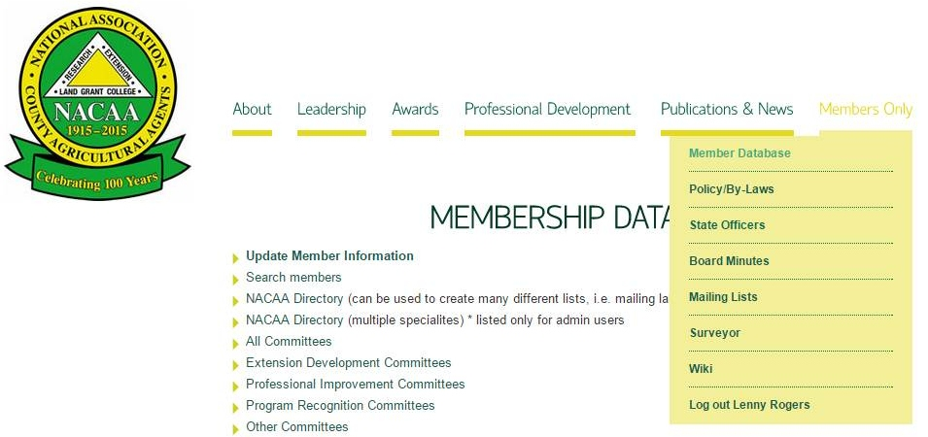

- From “Members Only” drop-down menu,
click on Member Database

- Click on Administrative Access Privileges
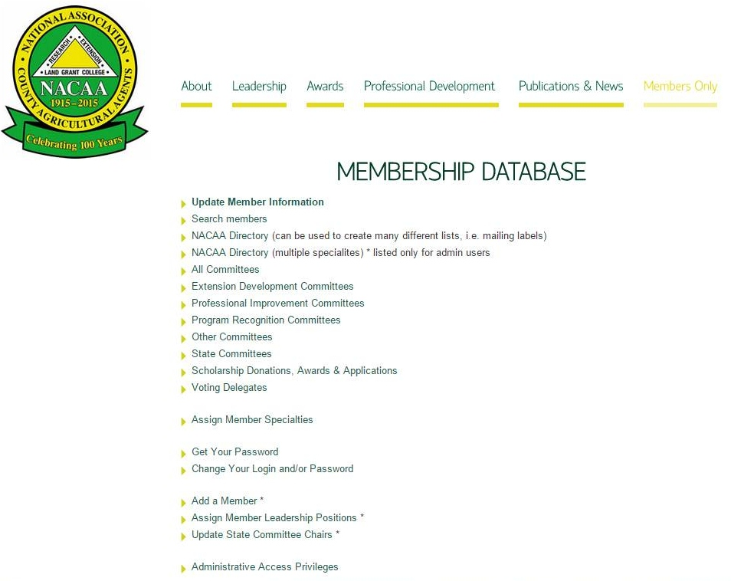

Check the list to insure you have access privileges to update your state’s listings.
- If you do not have access and need it, contact Scott Hawbaker, NACAA Executive Director at exec-dir@nacaa.com .
- If members from your state are listed who should no longer have access privileges to make changes, notify John so they can be removed from the list.
- Each state should limit the number of individuals with administrative access privileges.

To Update State Officer Positions:
From the NACAA homepage:
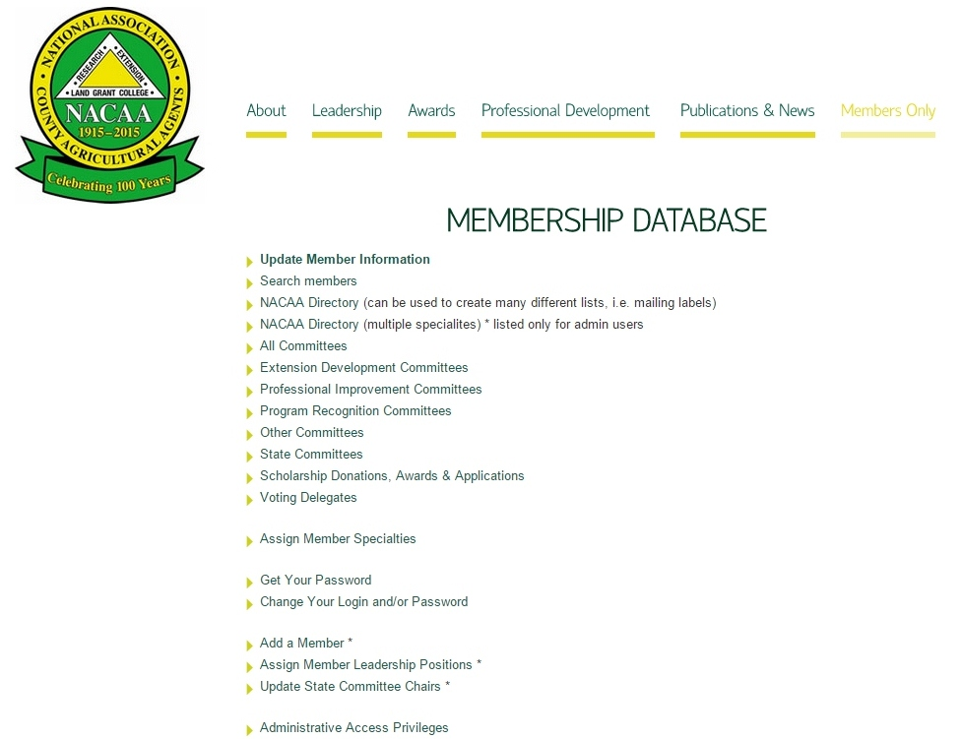
- Click on Member Database (see picture on previous page)

- Click on Assign Member
Leadership Positions
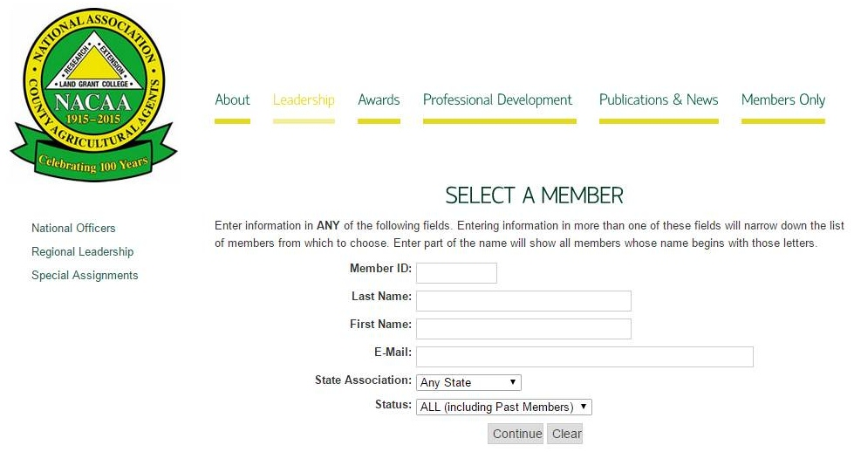

- Enter the last name of the member

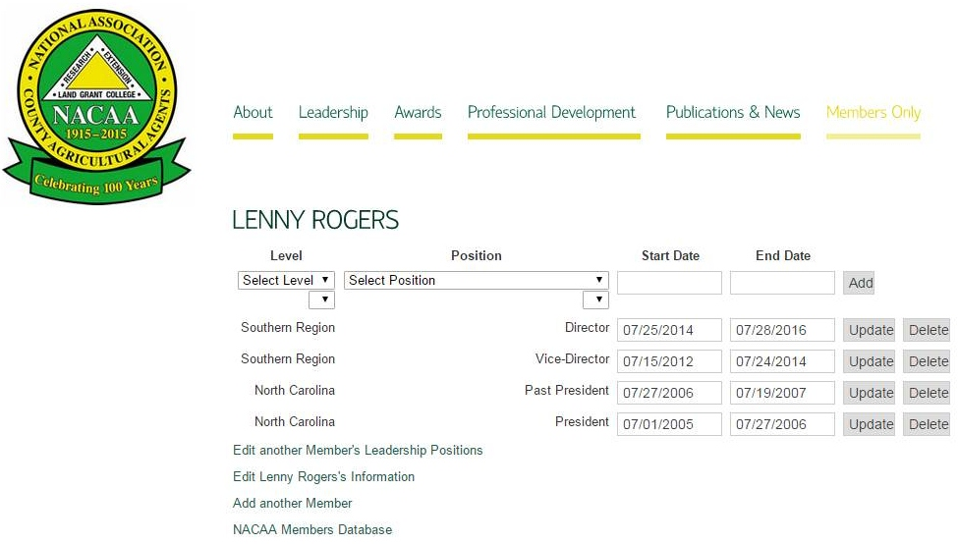
- If more than one member appears,
select the correct one
- Select the needed information,
from the drop down lists,
include the start and end dates
and click on the add box
- To edit another member click
on Edit another Member’s
Leadership Position

Note: When an end date passes, the member is no longer listed on the NACAA website for that position. States may want to provide some additional time to the end date to allow the next officer time to update the listings.
To Update State Committee Chair Listings:
From the NACAA Homepage:
- Click on Member Database (see picture on first page of Appendix)

- Click on Update State Committee Chairs
If you only need to change the start
and end dates for the person listed as
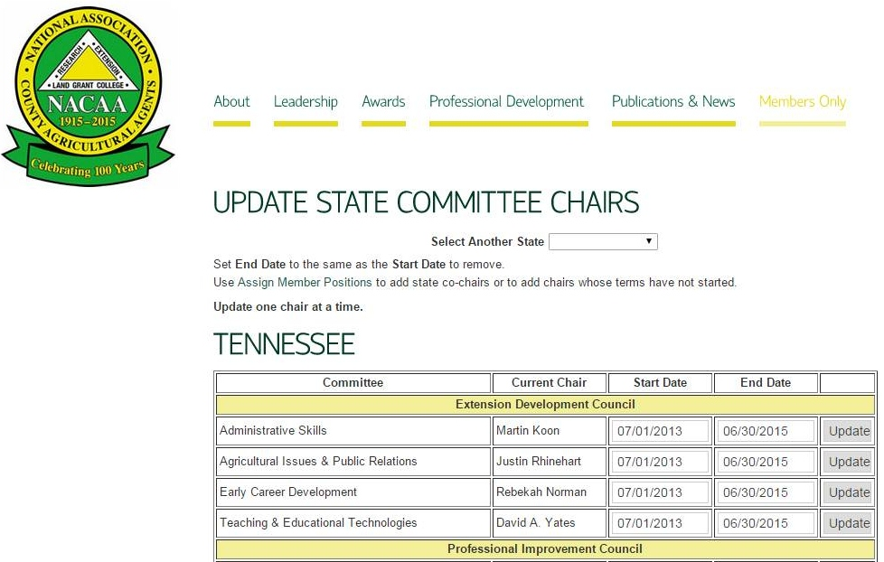
the committee chair, then change
the dates and click the update
box

- To assign a new person as a committee chair Click on Assign Member Leadership Positions. Select the level, committee chair and name of the committee from the drop down boxes; then input the start and end dates for the committee position and click the add box.
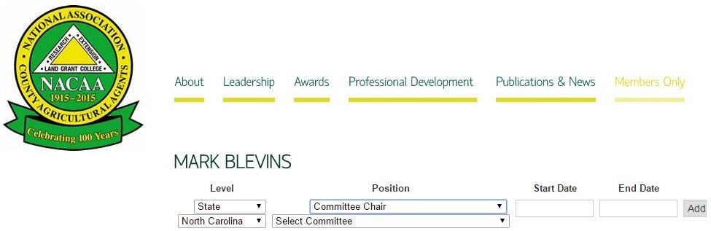

Appendix directions updated by Lenny Rogers, April 2015
How to Update State Membership Listings on the NACAA Website
as part of the dues submission process

First you must have administrative access to the NACAA website to update your state’s membership. If you are not assigned access for your state, contact Scott Hawbaker at exec-dir@nacaa.com to obtain access privileges.

Following are directions to update the membership listing:
- Go to www.nacaa.com
- Click on Member Database
- Click on State Dues Form, under the Miscellaneous Forms and Reports heading

New members should be entered first – renewing members handled below
To enter new members - click on the “Add a Member” link near the top of the page. Enter the each new member’s information and the year the dues are covering.

Renewing Members:
To update past members – click on the “Individual Dues” link near the top of the page.
Active members are listed on the state dues form page in alphabetical order.
- To update their dues paid status change the “Year” to reflect the year being paid for each person.
- If a member’s contact information needs updating, click on their ID # and make needed edits.
- If a person needs to be converted to a life member, select the life member box.

When completed:
- Click the Continue button at the bottom of the screen. A screen for life members and complimentary members will appear update as needed.
- A summary sheet will be available at the last page showing the amount payable to NACAA. Print this summary page and Include it with the payment.

The State Dues Form only shows members who were active in the previous year. If someone was a member a prior year, but is not shown on the state dues form, do not re-enter them as it might create duplicate entries. To renew a “previous member” click on “Individual Member Invoice”. Members renewed/added this way are not added to the state dues form page and are not included in the total payment calculation.

When NACAA receives the check and verifies the amount is correct the website will be updated to show a “paid” status.

For questions or problems with the dues submission process contact Scott Hawbaker via email at exec-dir@nacaa.com or call 217-794-3700.

